**SRI MUTHUKUMARAN ARTS AND SCIENCE COLLEGE**

**(Affiliated to university of Madras)**

**CHIKKARAYAPURAM, CHENNAI - 600 069.**

**DEPARTMENT OF PHYSICS**

**Under scheme of**

**NAANMUDHALVAN**

**Project Title: INDIA’S AGRICULTURAL CROP PRODUCTION ANALYSIS (1997-2021)**

**Submitted By**

**SANTHOSH R**

[**santhosh.r.73959@gmail.com**](mailto:santhosh.r.73959@gmail.com)

**SARIHA S**

[**sariha2203@gmail.com**](mailto:sariha2203@gmail.com)

**POORANI M**

[**poorani1352003@gmail.com**](mailto:poorani1352003@gmail.com)

**KALARANI R**

[**kalaraniramamoorthi2004@gmail.com**](mailto:kalaraniramamoorthi2004@gmail.com)

**Team Id: NM2023TMID34863**

**Under the mentor of**

**Mrs.V.VANITHA**

**Assistant Professor**

vanithavelaiya82@gmail.com

**Department of Physics**

**1. INTRODUCTION**

Today, India ranks second worldwide in the farm output. Agriculture is demographically the broadest economic sector and plays a significant role in the overall socio-economic fabric of India. Agriculture is a unique business crop production which is dependent on many climate and economy factors. Some of the factors on which agriculture is dependent are soil, climate, cultivation, irrigation, fertilizers, temperature, rainfall, harvesting, pesticide weeds and other factors. Historical crop yield information is also important for supply chain operation of companies engaged in industries. These industries use agricultural products as raw material, livestock, food, animal feed, chemical, poultry, fertilizer, pesticides, seed and paper. An accurate estimate of crop production and risk helps these companies in planning supply chain decision like production scheduling. Business such as seed, fertilizer, agrochemical and agricultural machinery industries plan production and marketing activities based on crop production estimates

Under these circumstances, higher agricultural growth is critical. It is a matter of concern for policy planners, planners and researchers in recent times. Sustained agricultural growth, which is facilitated by constant policy and institutional support, could foretell growth in the rural economy and associated secondary activities (e.g., food processing and retail trading). However, policy makers in the country have not given enough attention to agriculture-led rural industrialization. This is despite the fact that agricultural growth per se was not visible during the 1990. It is pertinent to note that, the growth performance of agriculture was remarkable during the 1980s. In fact, deceleration during the 1990s was attributed to the reduction in and/or stagnation of public expenditure on agricultural infrastructure, defunct extension services, and biased economic reforms. The first two decades of the twenty first century has shown the remarkable agriculture growth, particularly during COVID-19 period when other sectors of the economy contracted. This can be largely attributed to the renewed policy thrust from the government to revive agricultural growth through various development programmes, such as are Interest Subvention on crop loans and interest subvention on prompt repayment, National Food Security Mission, the National Agriculture Development Programme (Rashtriya Krishi Vikas Yojana), Pulses Development Programme, E-NAM, National Mission for Sustainable Agriculture, Pradhan Mantri Krishi SinchaiYojana, Paramparagat Krishi Vikas Yojana, Pradhan Mantri Fasal Bima Yojana, Gramin Bahndaran Yojana, Livestock Insurance Scheme, Micro Irrigation Fund, PM-Kisan, Soil Health Card (SHC) Scheme, Agricultural Export Policy-2018, Agri Startups, KCC scheme extended to animal husbandry and fishery farmers, Kisan Sampada Yojana, Mission for Integrated Development of Horticulture, Agriculture Infrastructure Fund, National Mission on Oilseeds and Oilpalm, Promotion of Farmer Producers Organisations, National Project on Organic Farming and MSP at levels of one and half times of the cost of production of 23 major crops, etc. Implementation of these programmes has contributed to agricultural growth and augmented farmers’ income in the country while allowing state governments to better leverage and allocate resources to the priority areas of development. In recent times, trends in India’s agricultural growth are relatively well researched themes. Systematic efforts have been made to examine crop output growth and its elements through decomposition analysis (Joshi et al. 2006). The present paper is likely to contribute to the existing knowledge on Indian agriculture by estimating crop output growth through econometric methods. It also discusses the trends in agricultural growth at national level.

**1.1** Overview

While agriculture’s share in India’s economy has progressively declined to less than 15% due to the high growth rates of the industrial and services sectors, the sector’s importance in India’s economic and social fabric goes well beyond this indicator. First, nearly three-quarters of India’s families depend on rural incomes. Second, the majority of India’s poor (some 770 million people or about 70 percent) are found in rural areas. And third, India’s food security depends on producing cereal crops, as well as increasing its production of fruits, vegetables and milk to meet the demands of a growing population with rising incomes. To do so, a productive, competitive, diversified and sustainable agricultural sector will need to emerge at an accelerated pace. India is a global agricultural powerhouse. It is the world’s largest producer of pulses, and spices as well as the largest area under wheat, rice and cotton. It is the second largest producer of rice, wheat, cotton, sugarcane. . The country has some 195 m ha under cultivation of which some 63 percent are rain fed (roughly 125m ha) while 37 percent are irrigated (70m ha). In addition, forests cover some 65m ha of India’s land.

## ****Purpose****

Raising agricultural productivity per unit of land: Raising productivity per unit of land will need to be the main engine of agricultural growth as virtually all cultivable land is farmed. Water resources are also limited and water for irrigation must contend with increasing industrial and urban needs. All measures to increase productivity will need exploiting, amongst them: increasing yields, diversification to higher value crops, and developing value chains to reduce marketing costs.

Reducing rural poverty through a socially inclusive strategy that comprises both agriculture as well as non-farm employment: Rural development must also benefit the poor, landless, women, scheduled castes and tribes. Moreover, there are strong regional disparities: the majority of India’s poor are in rain-fed areas or in the Eastern Indo-Gangetic plains. Reaching such groups has not been easy. While progress has been made - the rural population classified as poor fell from nearly 40% in the early 1990s to below 30% by the mid-2000s (about a 1% fall per year) – there is a clear need for a faster reduction. Hence, poverty alleviation is a central pillar of the rural development efforts of the Government and the World Bank.

**2. PROBLEM DEFINITION AND DESIGN THINKING**

**2.1 Empathy Map**

**Full Page Screen Shot**

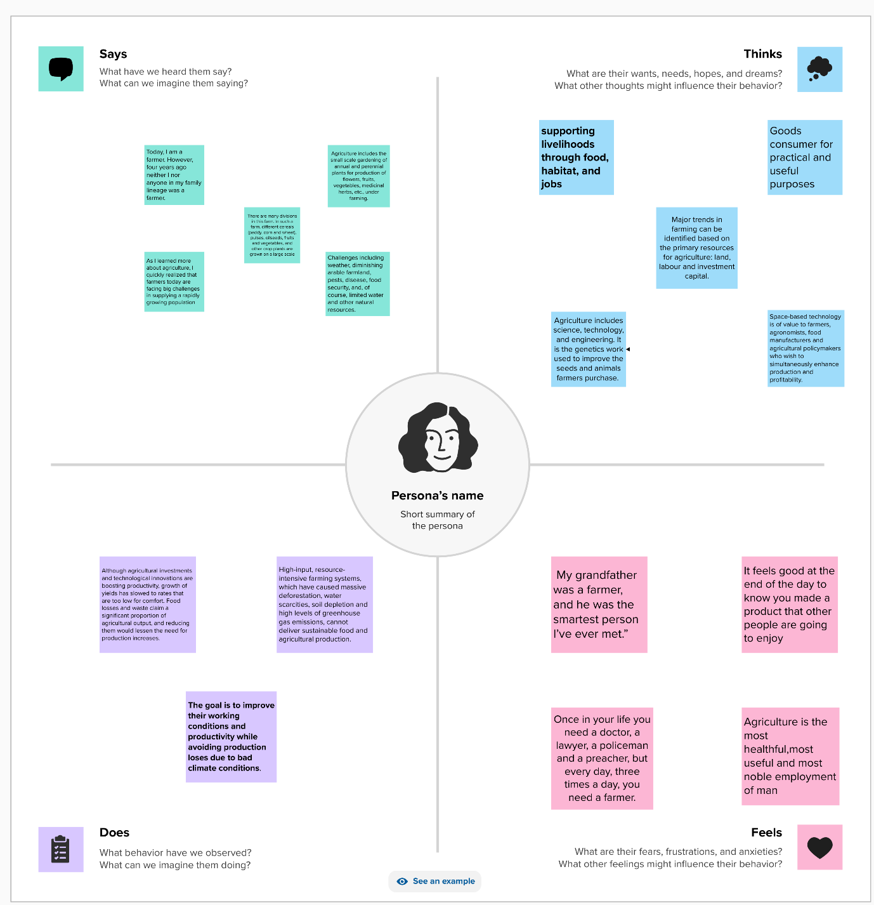

**2.2 Ideation and Brainstorming Map Screenshots**

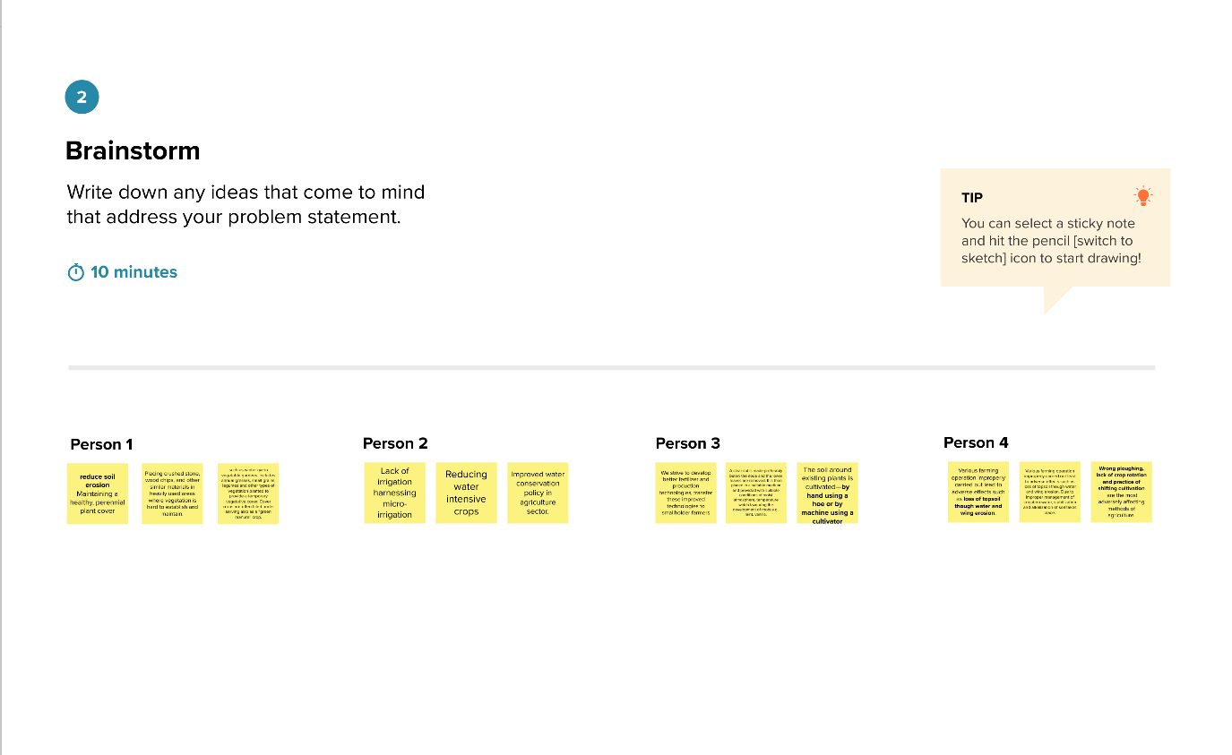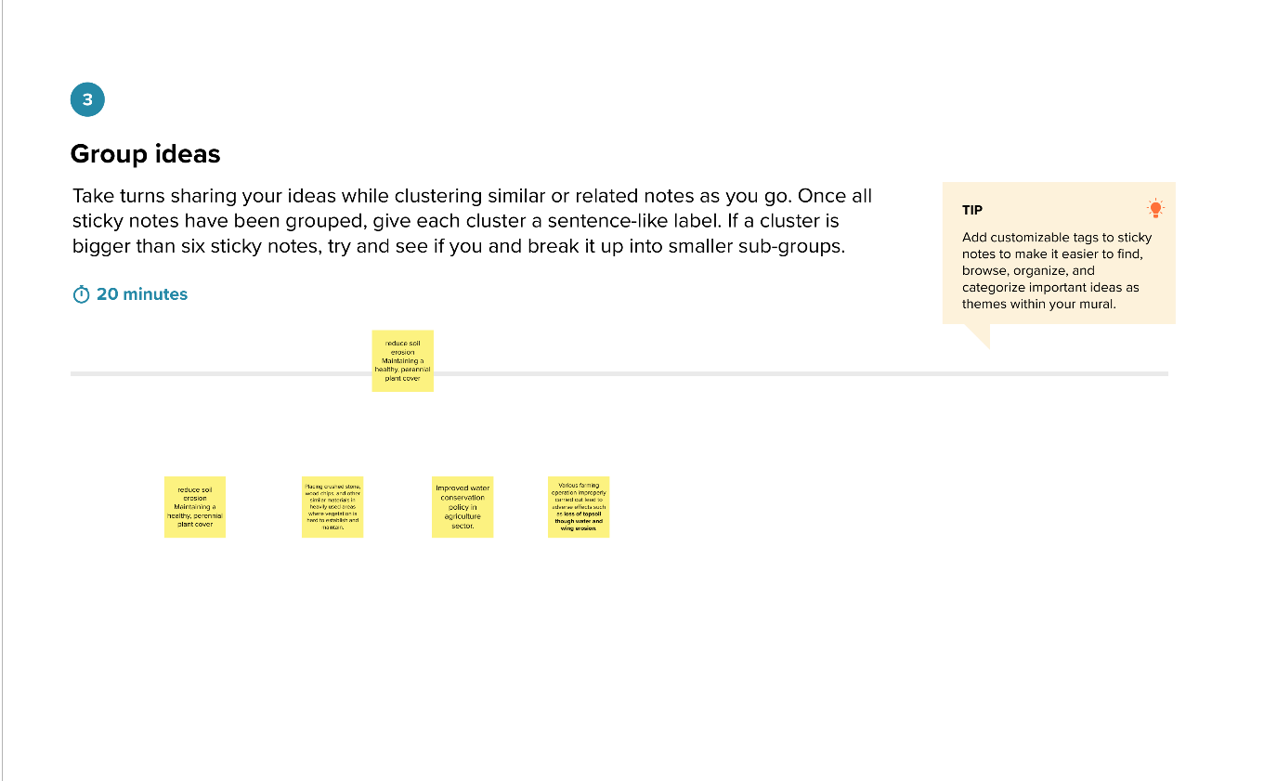

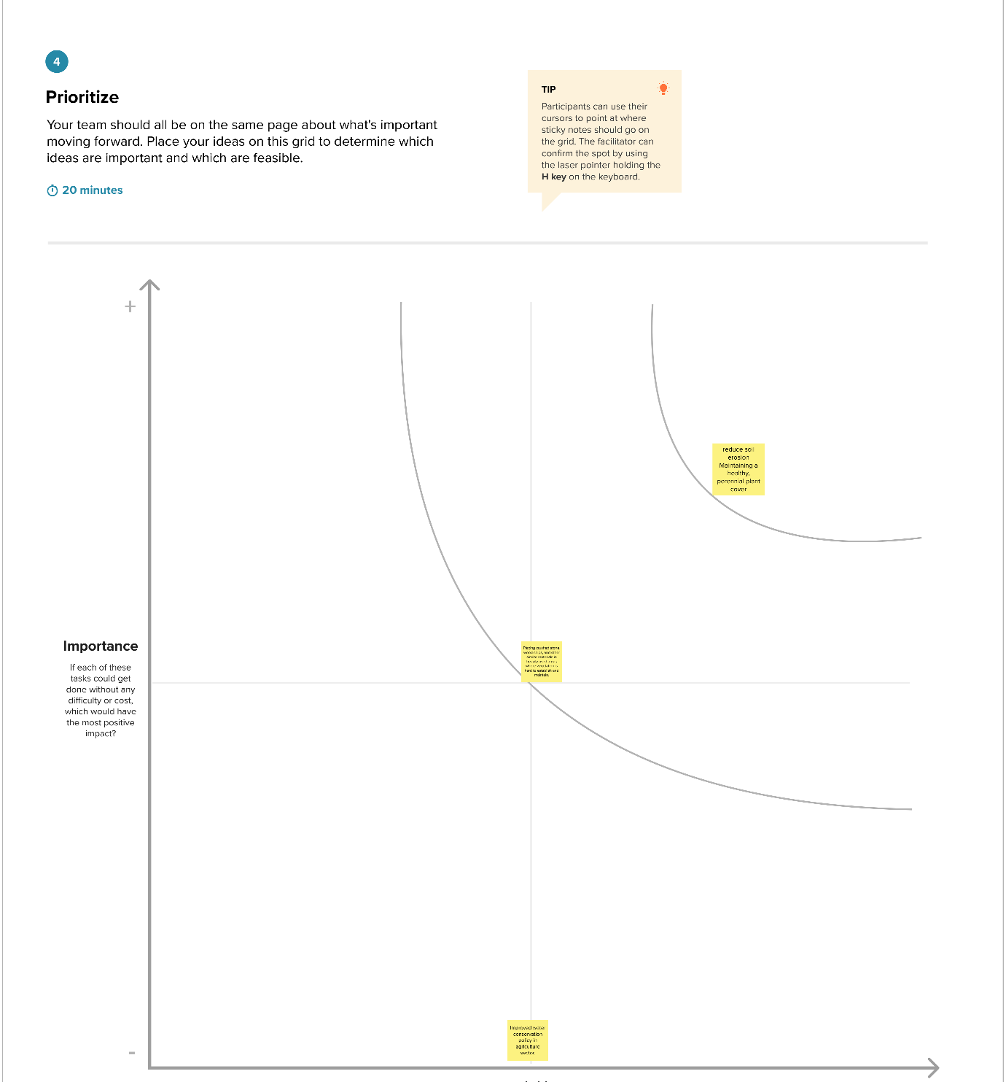

**3. Result**

Statewise Agricultural Land

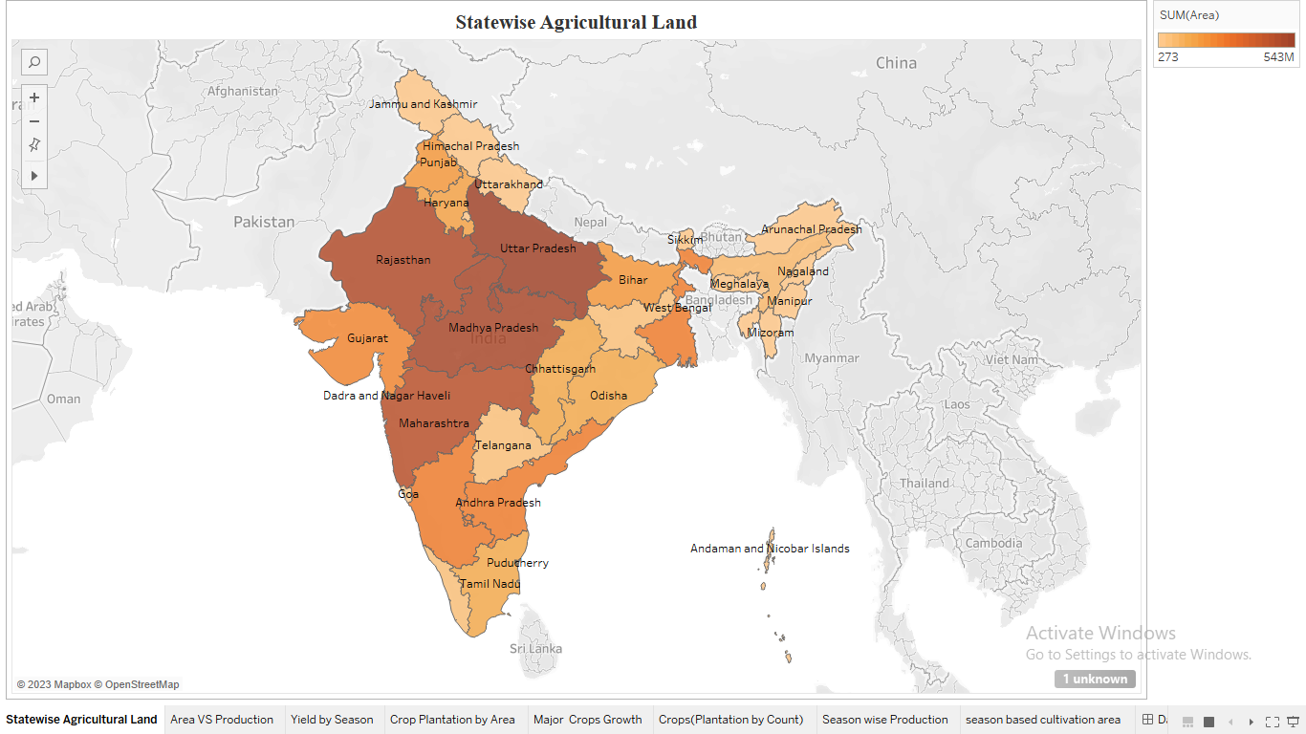

Area VS Production

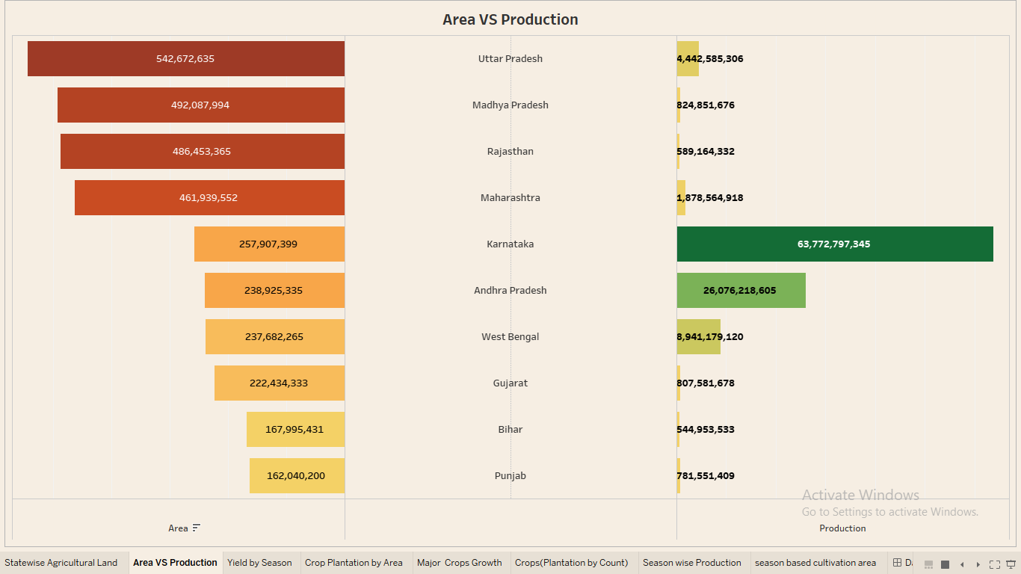

Yield by Season

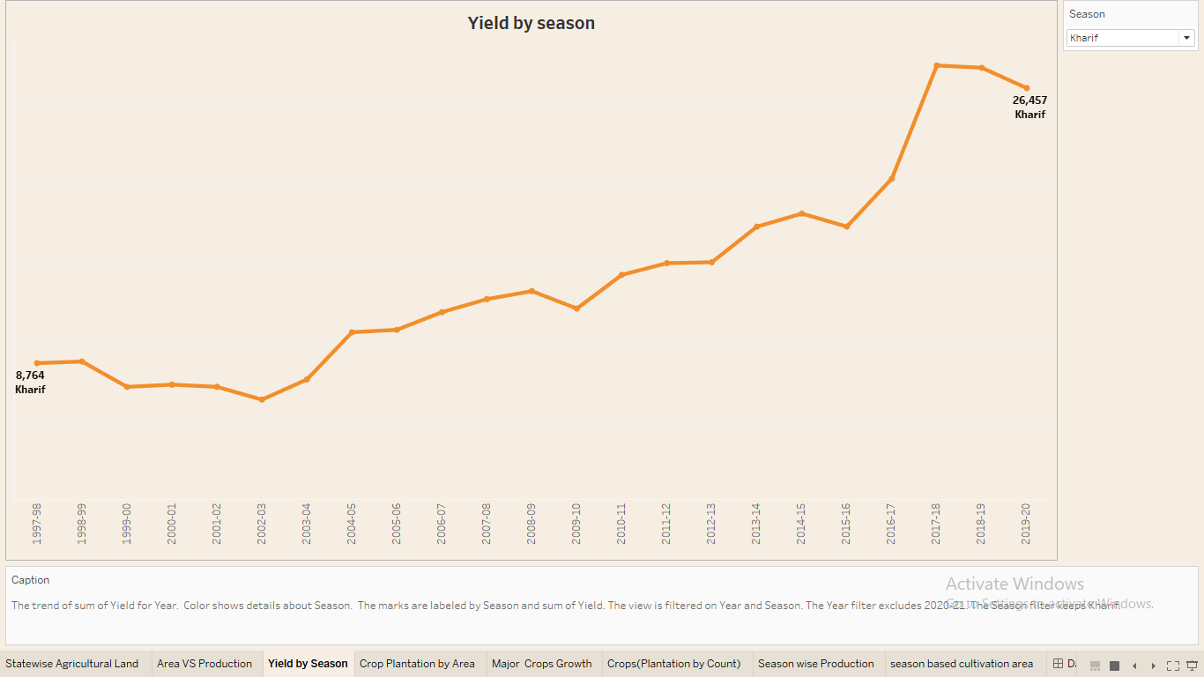

Crop Plantation by Area

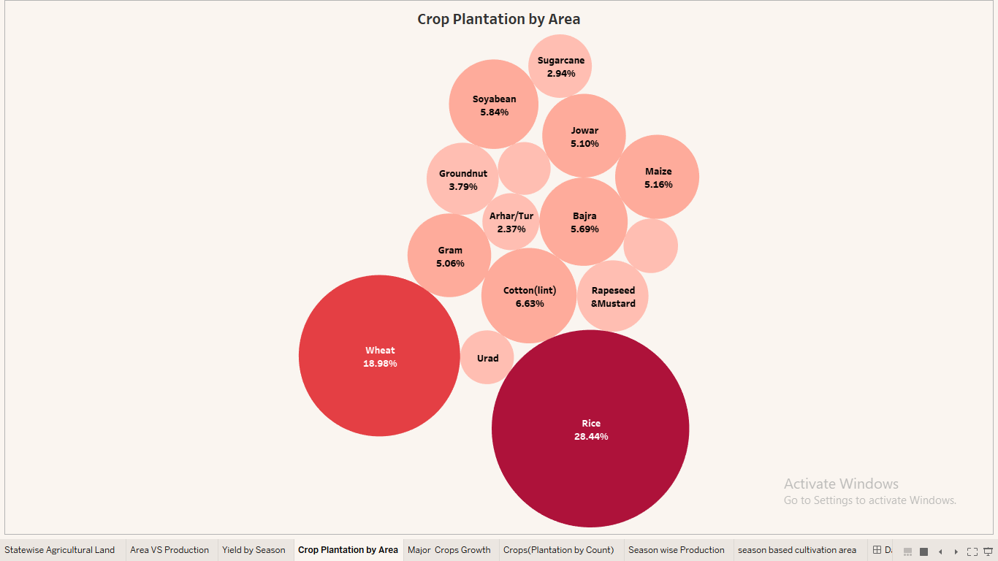

Major Crops Growth

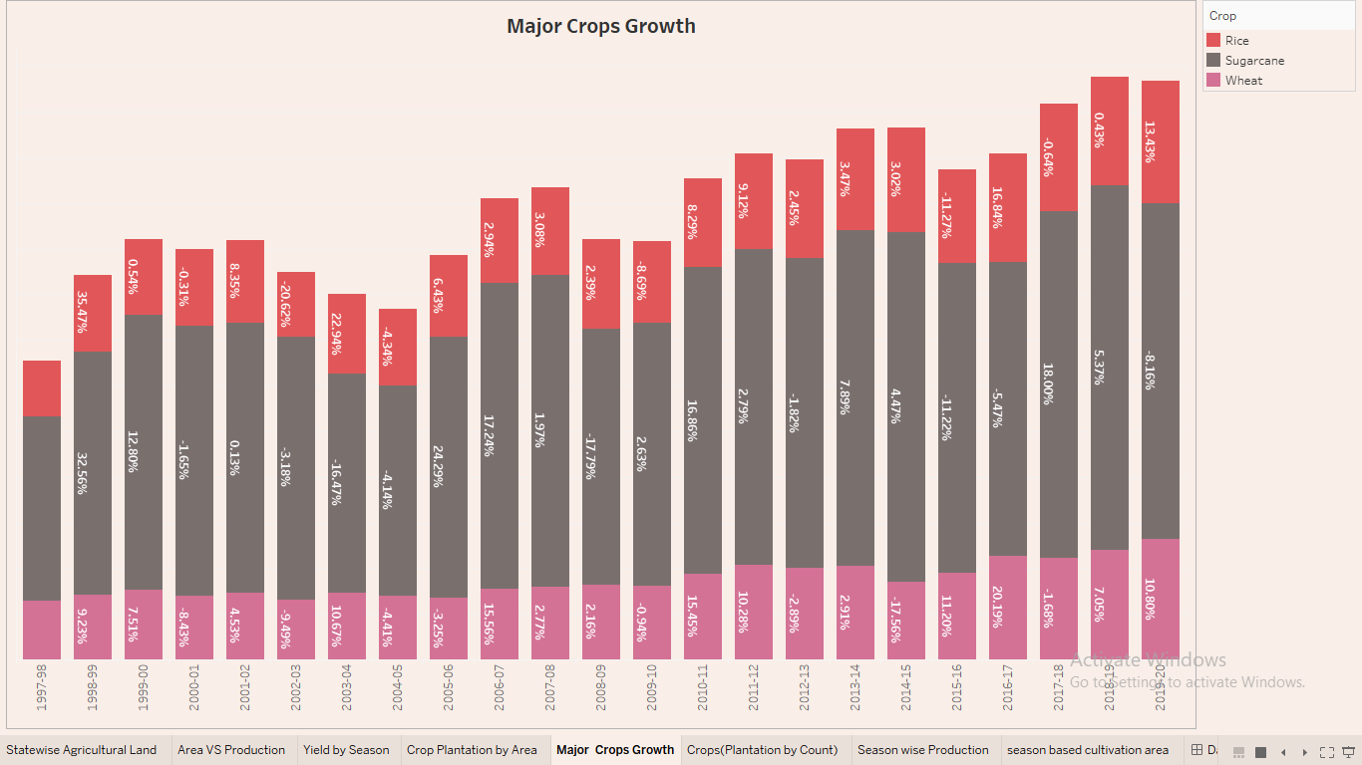

Crops (Plantation by Count)

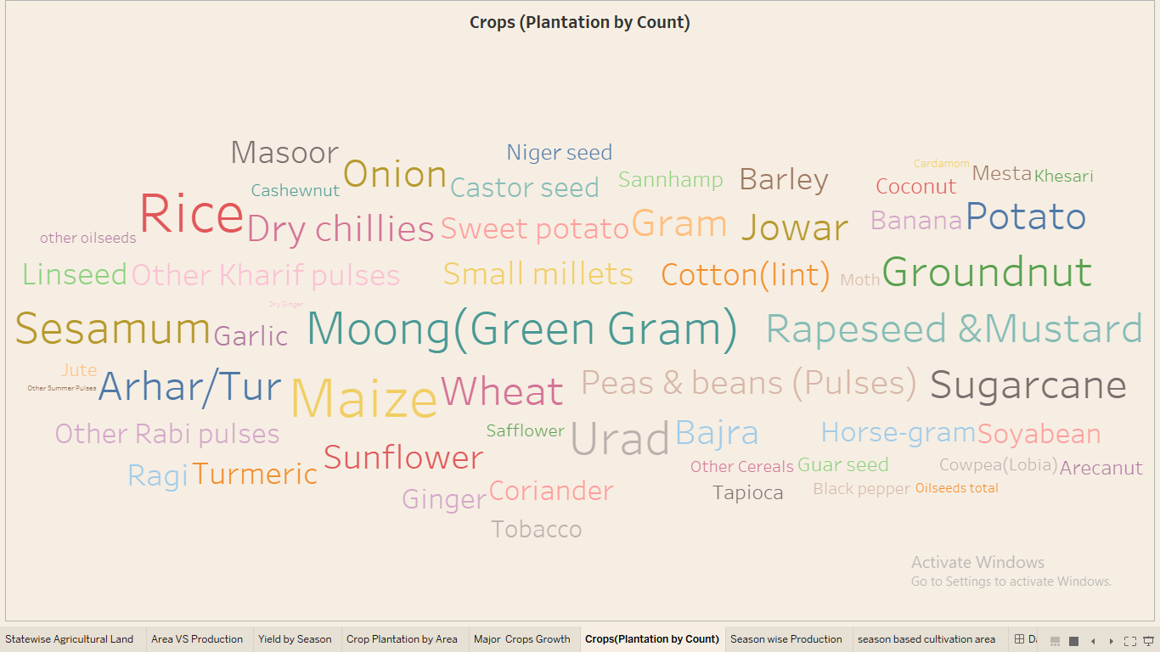

Season Wise Production

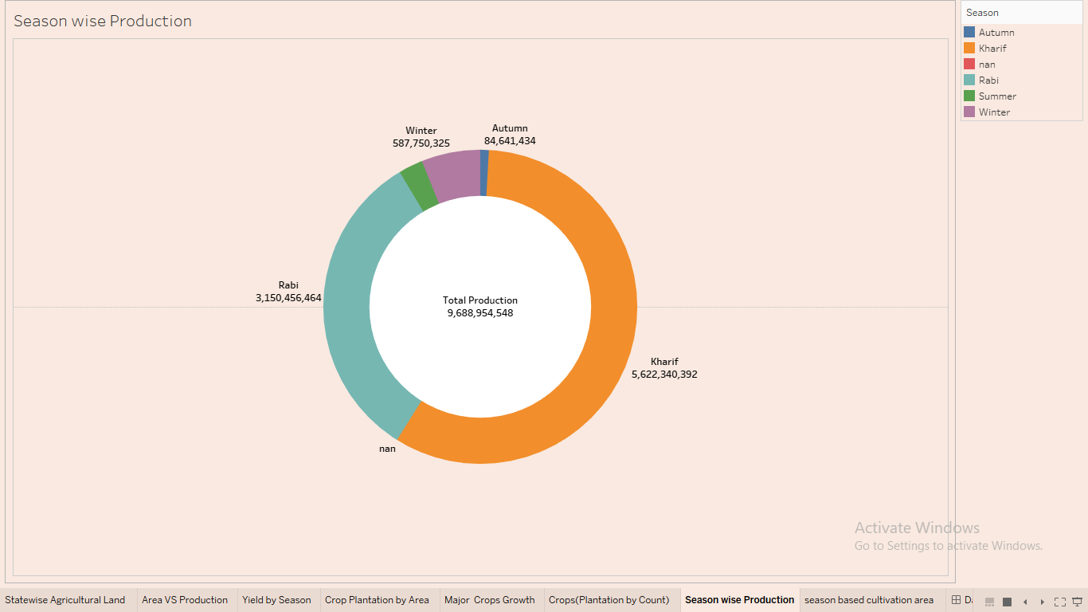

Season Based Cultivation Area

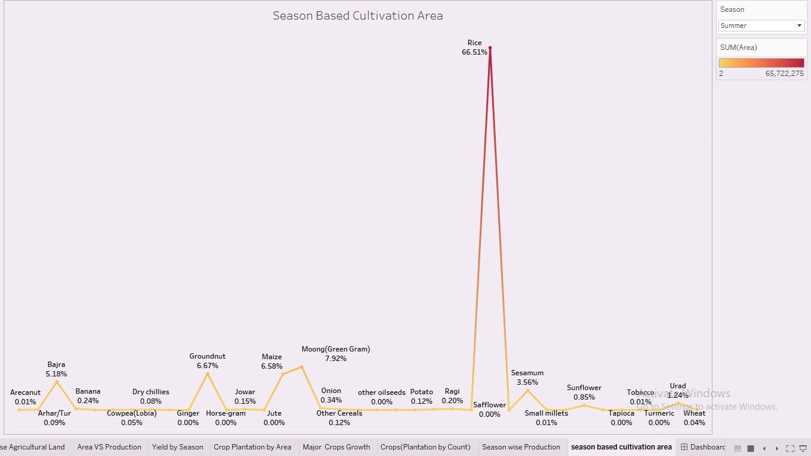

Dashboard 1

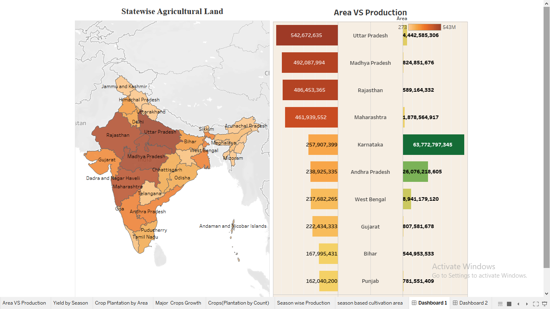

Dashboard 2

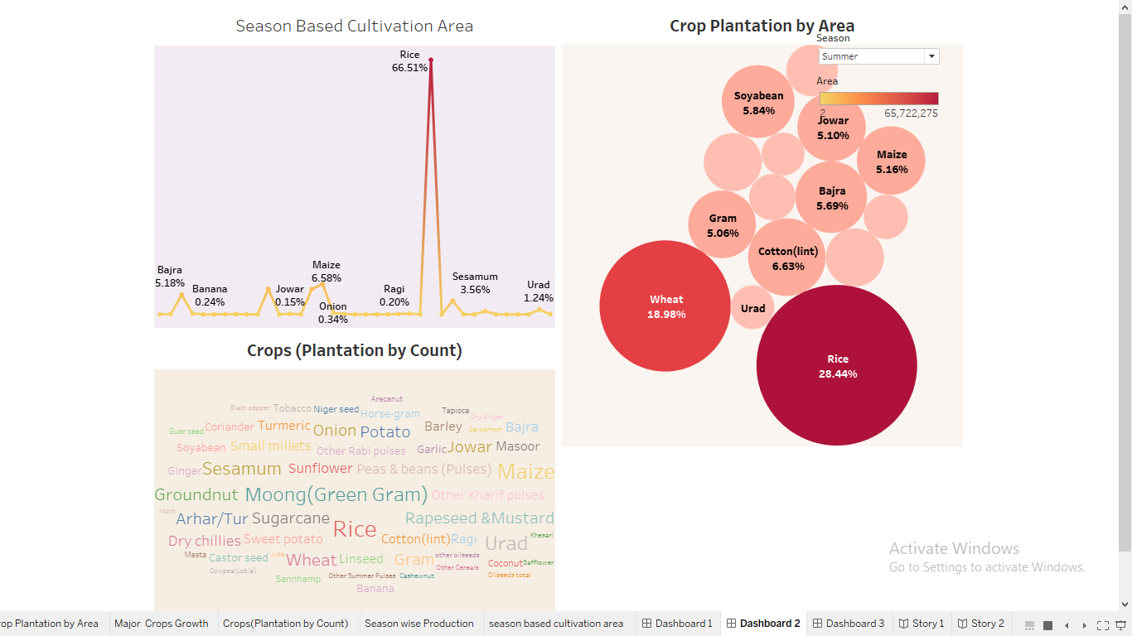

Dashboard 3

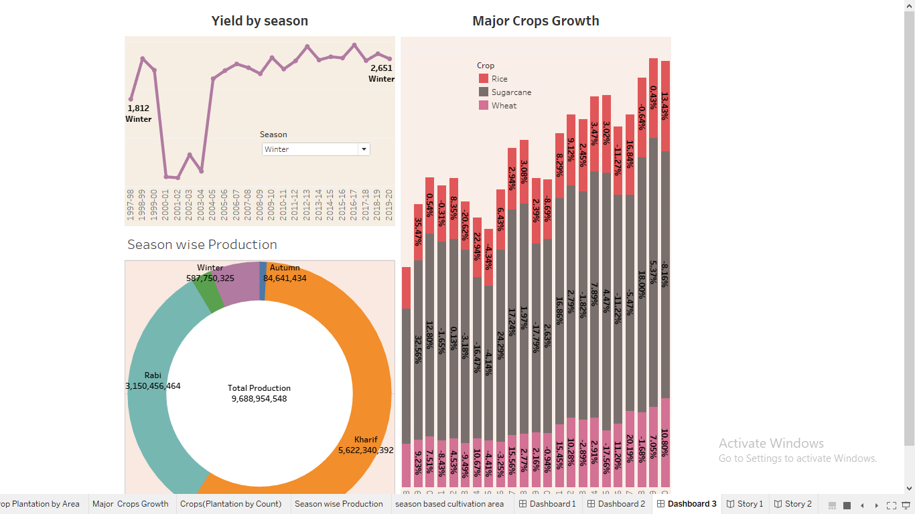

Dashboard

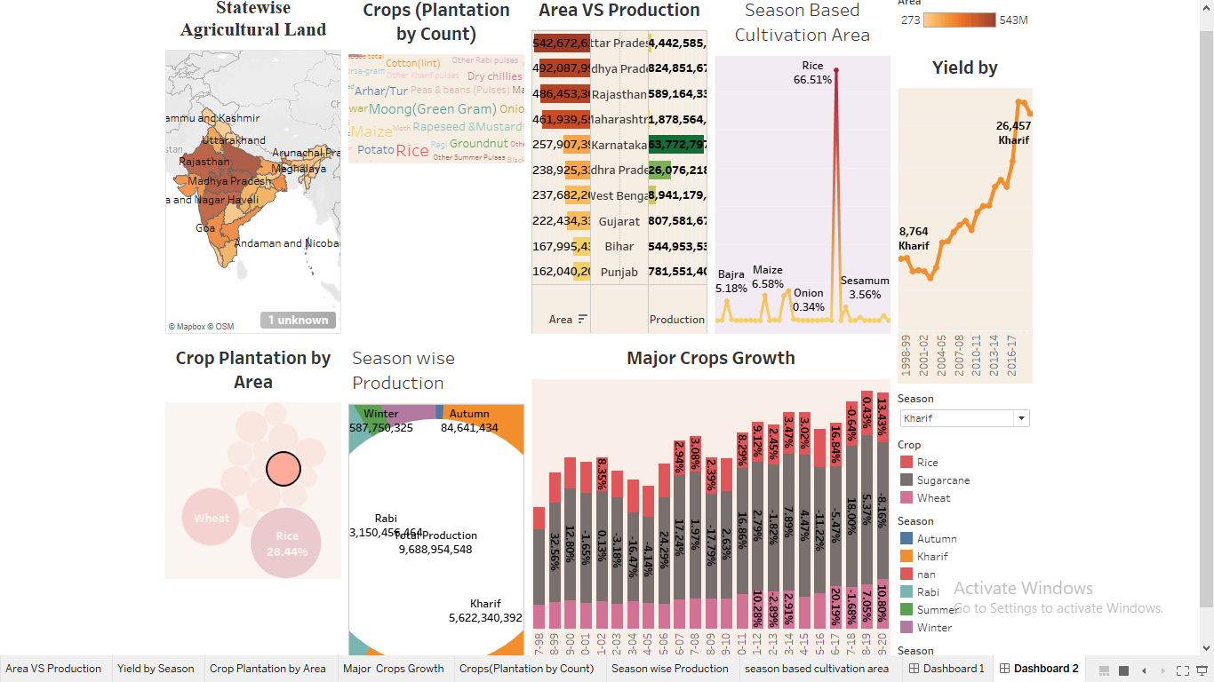

Story 1

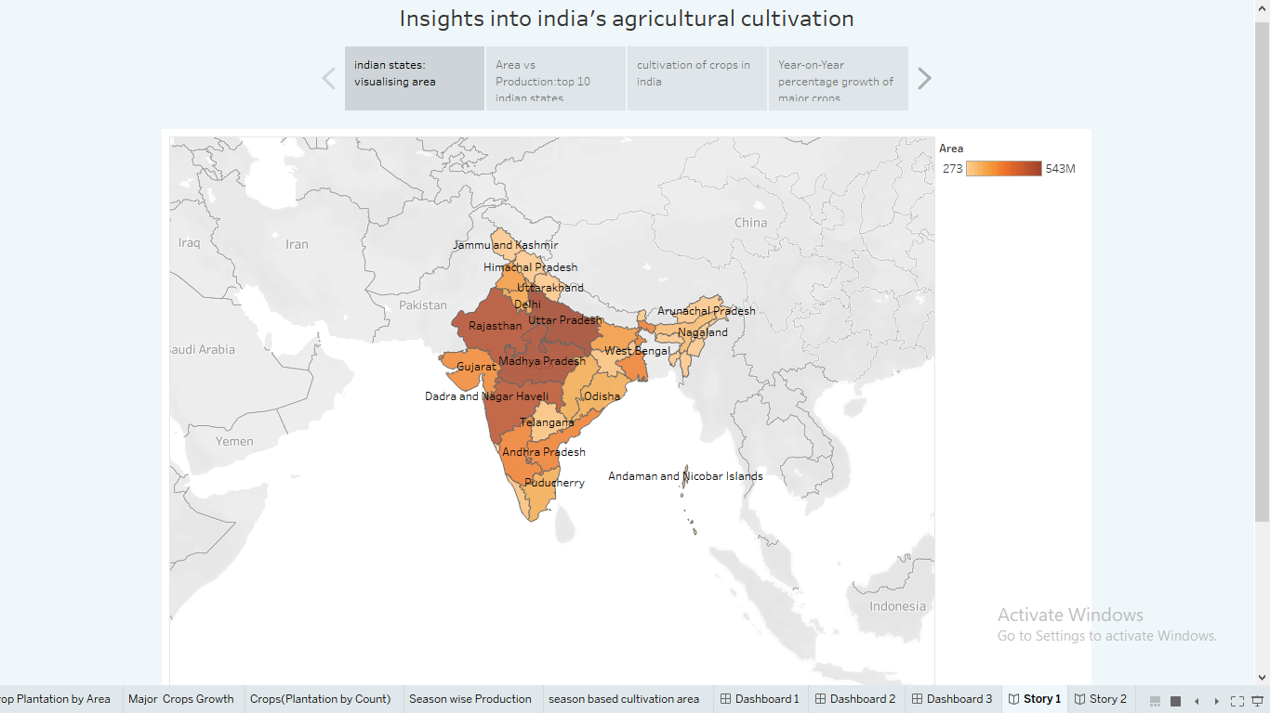

Story 2

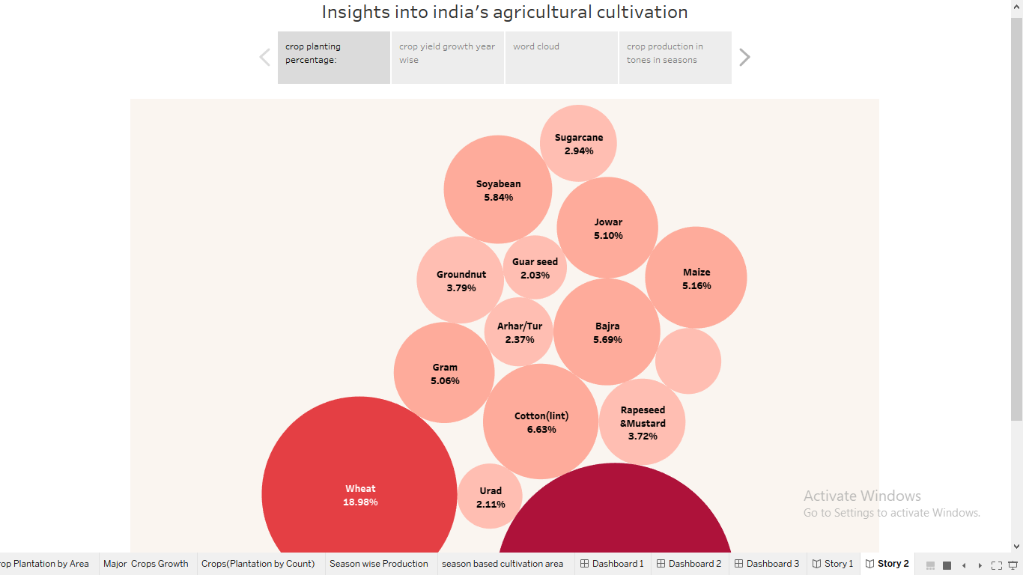

## ****4. Advantages and disadvantages****

**Advantages of agricultural**

* Contribute to improving the sharing of agricultural information resources, thereby increasing agricultural productivity and promoting the healthy and stable development of the agricultural industry.
* It is helpful to strengthen the communication between different agricultural regions, promote agricultural production to industrialization, and the development of production standardization, and enhance the competitiveness of the agricultural economy.
* It is helpful to promote the development of agricultural economy in multiple directions and transform the traditional agricultural economic management mode.
* It is helpful for farmers to quickly and comprehensively understand the dynamic information of the agricultural market, thereby adjusting the agricultural structure, producing agricultural products with large market demand, obtaining higher economic benefits, and promoting rural economic development, and realizing agricultural product marketing information management in agriculture The application in the economy plays an important role in promoting the development of agriculture in our country.

**Defects of agriculture**

* Lack of professional and technical personnel because the application of information technology to design agriculture is relatively late and the application time is relatively short, there is a shortage of professional information technology talents in agricultural. In addition, the construction of information networks for some rural public utilities is not perfect, causing farmers to be unable to obtain corresponding information in a timely manner and hindering the development of rural.
* Lack of a perfect platform most local government departments do not have a high level of understanding of agricultural modernization. Under the background of the information age, the development of agricultural economy needs to rely on strong support from government departments. Only when the government correctly analyses the conditions of the agricultural economic market can it guide the rapid agricultural economy Stable development.
* Farmers’ informatization awareness is weak some relatively backward areas are not deep enough in agricultural management concepts, agricultural economic development and information management to effectively guide local farmers in construction. This problem has seriously hindered the process of agricultural economic construction and information management. To sum up, in order to keep up with the development trend of agriculture in the information age, in terms of information resources, it is necessary to guide the government to build an agricultural information platform and cultivate professional technical personnel based on the current situation of agricultural resources and the current situation of agricultural development. The method of combining scientific development and modern technology has achieved economic benefits for agricultural products management.

## 5. Applications of Agriculture:

At present, Internet technology has been widely used in rural economic construction, which plays a vital role in improving the level of rural economic management and ensuring rural economic development, and has become an inevitable trend in the reform and optimization of my country's agricultural economic management system. With the aid of modern science and technology, it has greatly promoted the improvement of agricultural production efficiency and transaction volume, and cannot effectively increase the economic income of farmers. In addition, in order to support the construction of rural economic management information, local governments should increase capital investment and personnel training. Integrate agricultural production information resources to promote the stable and healthy development of agriculture. This shows that in the process of agricultural economic management, the government needs to make full use of information technology to control and guide the stable and healthy development of agricultural economic information technology, vigorously support the cultivation of information technology and agricultural economic management related talents, and guide farmers in daily agricultural production.

## ****6. Conclusion:****

In the process of studying the advantages and disadvantages of agricultural economic management informatization, this paper uses the agricultural data collection system as the test platform, the agricultural economic management informatization as the experimental group, and the traditional agricultural economic management as the control group. The simple scale is used to evaluate the data processing ability of the two groups. In the comparative analysis, the experimental group can effectively improve agricultural data collection capabilities and village information management capabilities, enabling effective integration of various data and information sharing. Optimizing traditional agricultural economic management methods is the general trend. Overcoming the shortcomings of agricultural economic management information can not only effectively increase farmers' economic income, but also greatly promote the development of the national economy

Agriculture is an important sector of the country. It is one of the market-driven industries that employ a large segment of the country’s population. The new changes over the last few years have been enormously helpful to contribute more towards economic growth. Recent advancements such as drones, and data-driven facilities help to monitor the process of farming. It has been supporting farmers to increase productivity and contribute more towards the agricultural economy.

The future of Indian agriculture seems bright and promising with the advent of new technologies. The government has increased its focus on the sector, implementing various policies and initiatives to boost productivity and growth. India’s vast and diverse agricultural landscape, coupled with advancements in technology, provides immense opportunities for farmers to harness their potential and increase yield. In addition, start-ups in the agricultural sector are working towards providing innovative solutions to farmers in terms of supporting them with better productivity, measuring tools and other data-driven strategies.

## 7. Future scope:

**Recent Trends in Agriculture**

India’s agriculture mainly depends on nature, however changing climate and global warming are making farming unpredictable. The need to use modern technologies to increase productivity and profitability led to the emergence of Agriculture 4.0 in India. There have been significant changes in India in the context of agriculture over the decades and many new technologies have been developed. Several new-age farmers are using soil mapping software as well to determine the optimum level of fertilizers used in the farms. These emerging technologies in farming and agriculture pave the way for more opportunities. The argotic start-ups and traditional farmers are also using the latest solutions and trends to improve production solutions and other relevant advanced agricultural management techniques to increase farmer efficiency and produce more crops.

**Examples:**

Grape farmers in India who have begun spotting and geo-locating crop diseases or pestilence, allowing them to control infestations earlier and in a more precise manner. This also leads to lower use of harmful pesticides on the crop. Soil mapping software is used by several new farmers to determine the optimum level of fertiliser use in their farms. They are also using drones which allow spraying pesticides in a more targeted manner.

Sugarcane farmers in India have started using technology to gauge the most appropriate time to harvest their crops, which allows them to better plan their harvest and maximise output. Several Indian farmers have also begun to use AI/ML-powered technologies to forecast crop yield, weather conditions and price trends in mantis. A few farmers have also begun testing self-driving tractors and seed-planting robots to free their farms from the vagaries of labour shortages.

Emerging trends in the agricultural sector that are quite prominent in the post-liberalization era include increased production, increased investment, diversification of the sector, use of modern techniques, development of horticulture and floriculture, increasing volume of exports and development of the food processing industry.

Some of the recent trends in agricultural technology:

1. **Agricultural Drone Technology-**

Drones are used widely for medical delivery to protection assistance and are used in agriculture to improve the growth of crops, maintenance, and cultivation methods. For example, these ariel carriers are used to access crop conditions and execute better fertilization strategies for more yields. Even the accessibility of hovering robots help farmers through a survey of large areas and data collection to generate better insights about their farms. Using drones in agriculture has provided more frequent, cost-effective remote monitoring of crops and livestock. It also helps analyse field conditions and determine appropriate interventions such as fertilizers, nutrients, and pesticides.

1. **Diversification of Agriculture-**

The agricultural sector produces generic consumption needs as well as crops like fruits, vegetables, spices, cashews, areca nuts, coconuts, and floral products such as flowers, orchids, etc. With the increasing demand for these products, there’s a huge potential in terms of production and trade of these products. This shows how the agricultural sector is being transformed into a dynamic and commercial sector by shifting the mix of traditional agricultural products towards higher quality products, with a high potential to accelerate production rates.

The diversification in agriculture is being supported by changes in technology or consumer demand, trade or government policy, transportation, irrigation, and other infrastructure developments.

1. **Increasing Trend in Horticulture Production-**

The availability of diverse physiographic, climatic, and soil characteristics enables India to grow various horticulture crops. It includes fruits, vegetables, spices, cashew, coconut, cocoa, areca etc. The total horticulture production in FY22 is estimated at 342.333 million tonnes which is an increase of about 7.03 million tonnes (2.10% increase) from 2020-21.

1. **Development of Agriculture in Backward Areas-**

In the post-green revolution era, the introduction of new agricultural strategies, research, and under the wave of liberalization, with the growing demand for agricultural exports, many new sectors of agricultural activities have become favourable and profitable.

In some agriculturally backward areas with no irrigation system and access to fewer resources, dry land farming has been introduced. Other activities were also encouraged such as horticulture, floriculture, animal husbandry, fisheries, etc. To support the development in those areas, various modern techniques have been installed in the backward areas.

1. **Ariel Imaging-**

Ariel imaging involves the use of geographic information system (GIS) technology to analyse the potential of irrigation projects and their impact on land degradation, erosion, and drainage. The visuals of this technology allow assessment of an individual plant’s foliage. These visuals are actively used to detect pests and diseases to protect crops from environmental threats. It mostly helps farmers to monitor the soil conditions of farms and is useful in the summer season when there is the least availability of water.

1. **Hydroponics and Vertical Farming**

The concept of hydroponics farming focus towards better yields, texture, and taste of the final extensive root systems and it allows them to contribute more energy towards the production of leaves and fruits. Because of indoor cultivation, these plants mature quickly and possess better immunity against pests and other diseases. In the context of sustainability, vertical farming allows farms to be located near or within areas of high population density which reduces the need for transportation and any harmful emissions. Vertical farming provides the ability to grow crops in urban environments and contributes to the availability of fresh foods conveniently. This farming significantly reduces the amount of land space required to grow crops compared to conventional farming methods.

1. **IoT in Agriculture**

IoT supports agriculture through the installation of various sensors in agricultural farms. These sensors are used to monitor light, humidity, soil moisture, temperature, crop health, etc. Some of the major uses of IoT in agriculture are as follows:

* 1. Various farm sensors such as autonomous vehicles, wearable’s, button cameras, robotics, control systems, etc help in the collection of data to analyse the performance of the farm.
  2. Use of aerial and ground-based drones for crop health assessment, irrigation, monitoring and field analysis.
  3. Use of tools to predict rainfall, temperature, soil, humidity, and other forecasted natural calamities.